

Fastmarkets Dashboard   
Release Notes

30th August 2024

**What’s New?**

**New Features**

This release of the Fastmarkets Dashboard includes new functionality and features including:

* **New** - **Export forecast prices** from Price Chart widget to Excel add-in
* **New – Introducing “forward curves”** to the Price Chart and Multi Price Table

Improvements to the Dashboard screen

* **Change –** **login screen** improvements
* **New functionality -** Easily **add new widget from any Marketpages** to your Workspace
* **Change** - More **prominent Scroll bars** in the Dashboard
* **New functionality** – **Maximise widget** to whole screen

**Export forecast prices from Price Chart widget to Excel Add-in**

This release introduces the ability to export forecast prices from the Dashboard using the Fastmarkets Excel add-in. Customers are now able to create a Price chart widget in the dashboard, add symbols with forecast and then export them into Excel.

This new functionality is enabled by the introduction of a new Excel add-in function for forecasts (called GetPriceHistoryWithForecast). The new function is an improved version on this existing historical data function with the following new capabilities:

* Ability to retrieve forecast prices together with price history
* Ability to retrieve data for multiple symbols within a single call

How to export forecast prices from the Dashboard?

1. Create a Chart widget
2. Add symbols which have forecast data

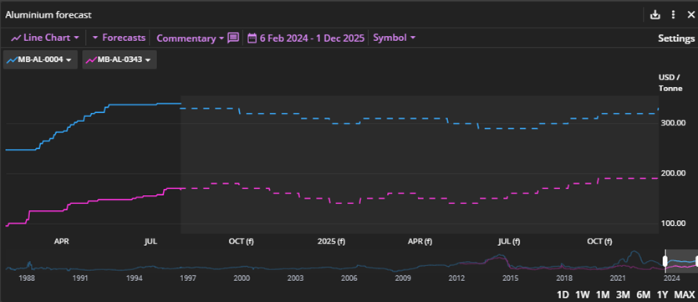

1. Click on the Export button
2. Select Copy for Excel add-in

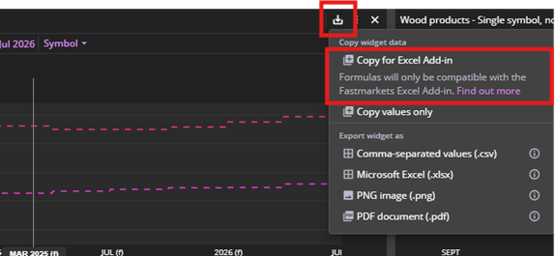

1. Select the cell in Excel here you want the data to be pasted

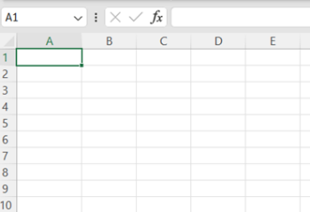

1. Click to paste it using “Ctrl + V” short cut and you will see the forecasts appear in the table alongside the timeseries

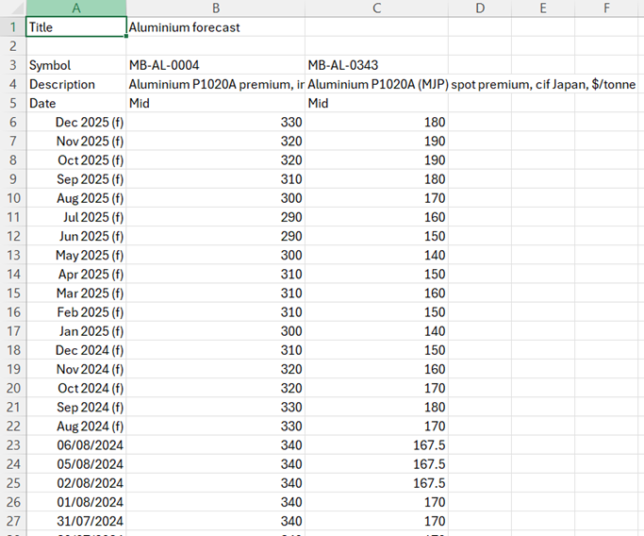

How can I add a symbol?

You can edit the widget in the Dashboard, add the symbol and export it again to Excel.

Alternatively, you can update the function directly in Excel.

1. Click on the cell that contains the function (A5 in this example)
2. Click on the fx icon

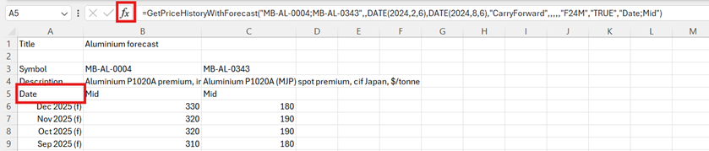

1. Edit the symbol parameter. Use semi-colons to separate the symbols, the syntax is the following: “symbol1**;**symbol2**;**symbol3”

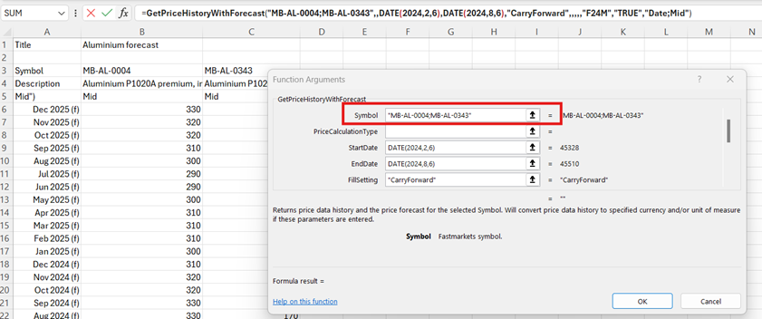

1. Once the symbol is updated, click OK

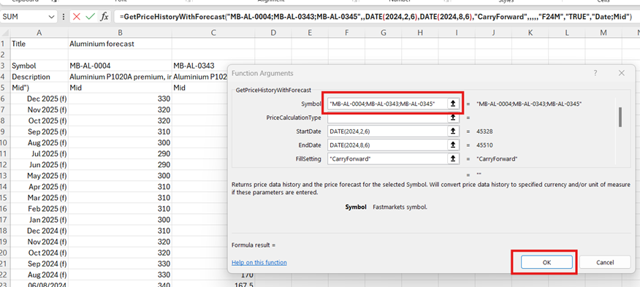

How can I change the fields?

You can change the fields in the widget in the Settings menu and export it again to excel.

Alternatively, you can update the function directly in excel.

1. Scroll down to find the Fields parameter

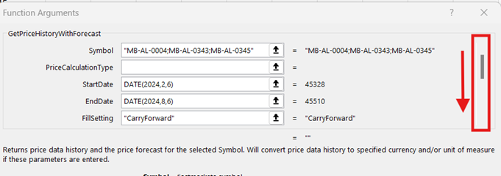

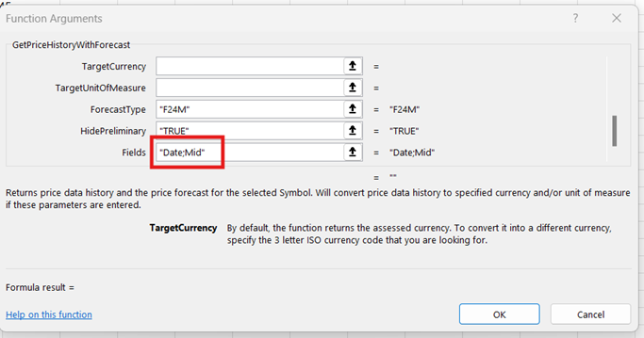

1. Update the Fields parameter. You can add/remove fields, make sure you add semi-colon to separate the fields. The syntax is Fields = “Field1;Field2;Field3”

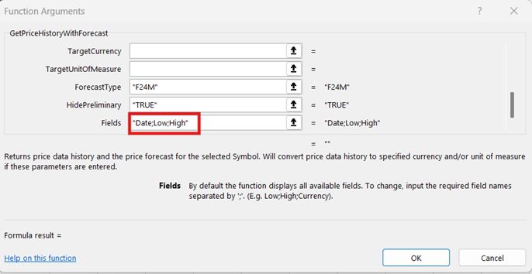

Can I export multiple symbols using ‘Values only’ Fill setting?

Yes, this is a new feature of the new GetPriceHistoryWithForecast function. In the past, if you added multiple symbols to a Chart widget, it was not possible to select Copy for Excel add-in (the button was disabled). The reason for this was that the previous historical data function didn’t support this Fill setting for multiple symbols. Now, as the new function is able to retrieve data for multiple symbols, it can create the ‘Values only’ table in Excel.

Steps:

1. Add multiple symbols to the Chart widget
2. Select Copy for Excel add-in
3. Paste it into your spreadsheet.

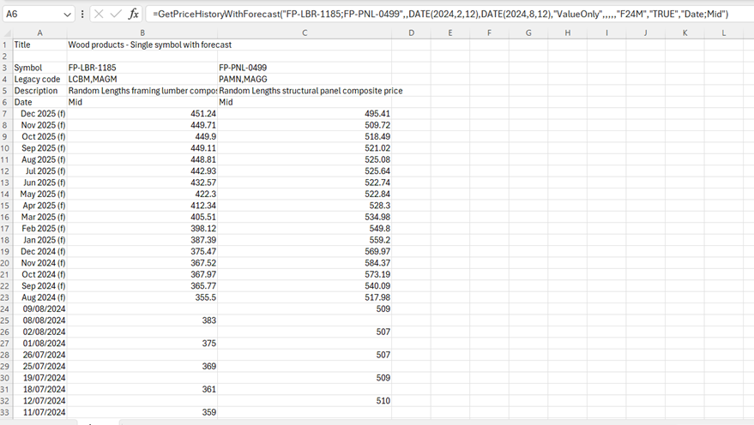

**Introducing “forward curves” to the Price Chart and Multi Price Table**

This release introduces “forward curves” to the Fastmarkets Dashboard. You can now access forward curves data in the Price Chart and Multi Price Table widgets. Also new price labels have been added to help identify the prices with forward curves available.

A quick overview and a step-by-step walkthrough of creating a “forward curve” widget follows.

Step 1 – Navigate to your desired Workspace and click “Add Widget”.

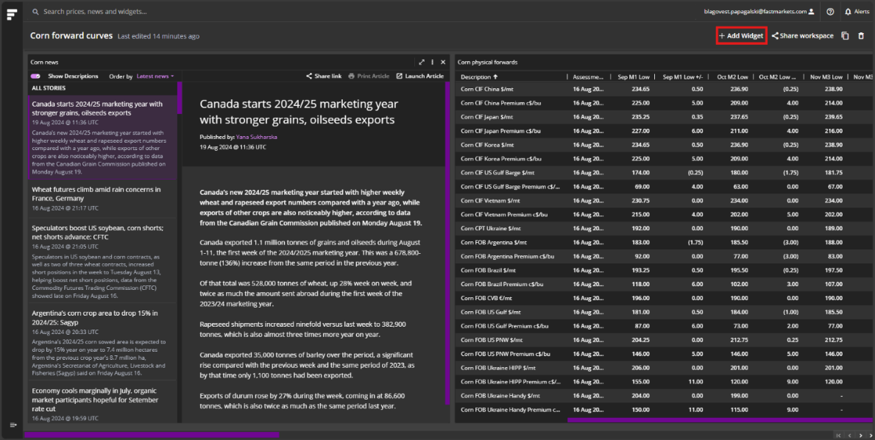

Step 2 – Select a Multi Price Table, or a Price Chart widget. These widgets have blue display labels showing they work with forward curves. Note that these widgets are the ones that support forward curves data visualization. Next steps are similar for both types of widget.

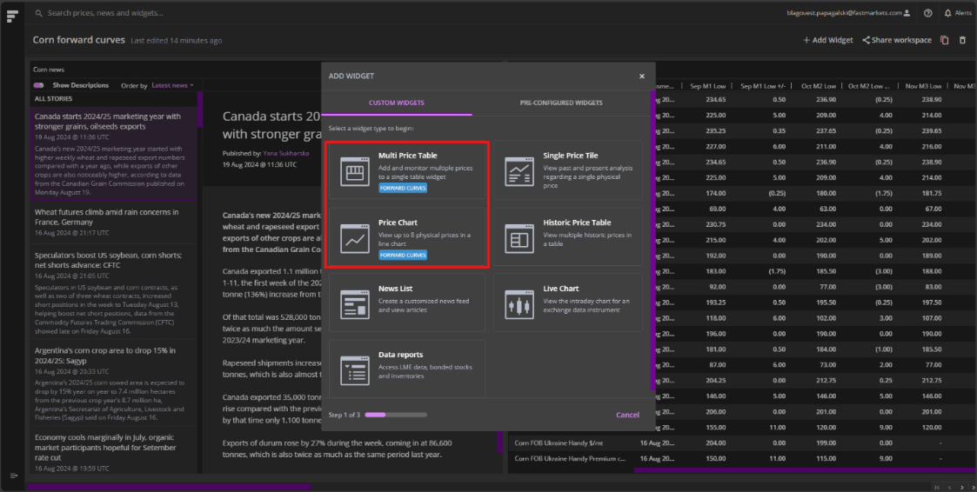

Step 3 – Select the required prices to add to the widget. **Please note there are blue labels now introduced, next to individual prices, indicating that a price can be shown as a forward curve.** This will allow you to distinguish which prices can be shown as a forward curve.

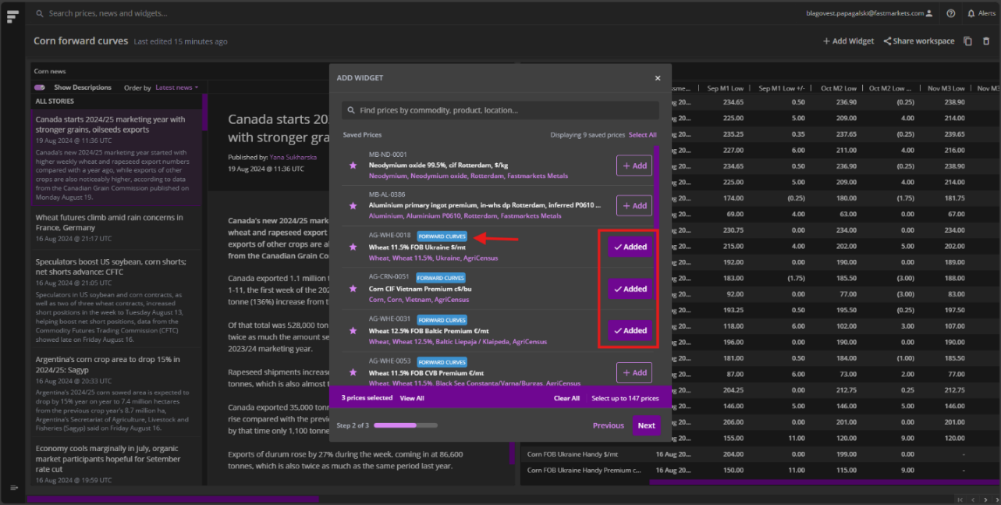

Step 4 – Ensure you select “forward curves” for your data visualization preferences. **This option has been made more prominent. This is a mandatory step to view forward curves in the selected widget.** Please note, if you select “Actual” instead of “Forward Curve” in the drop down, it will create the default widget type which lacks forward curve data.

Finally provide a title for the widget and click confirm.

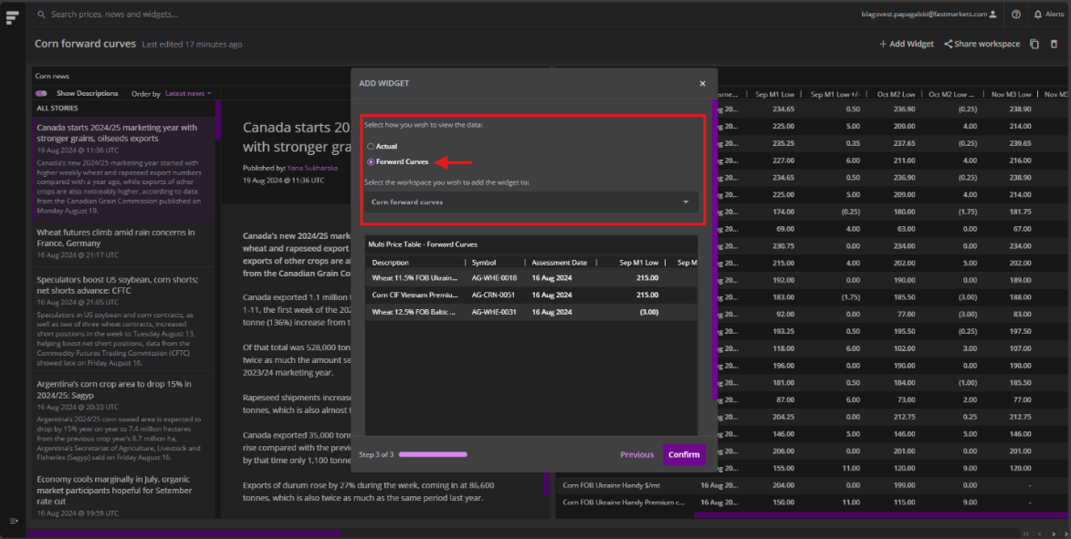

In this walkthrough, the example used is a Multi Price Table widget, but the steps are identical for creating a Price Chart widget with forward curves.

Here is an example of a Multi Price Table with a few prices with forward curves.

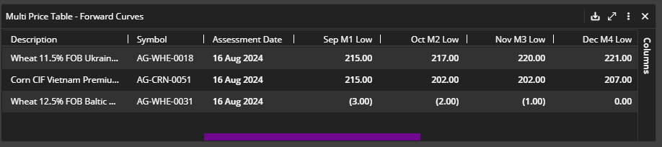

Tips for making the most out of the Multi Price Table with Forward Curves

* Ensure you have displayed columns that are available in the widget options, e.g. M1-M9, low/mid/high values, change since previous assessment, or any price properties you might need to see in the widget.
* Don’t forget you can export the data from the widget to the Fastmarkets Excel Add-in, and/or Excel.

Here is an example of a Price Chart with three of prices with forward curves.

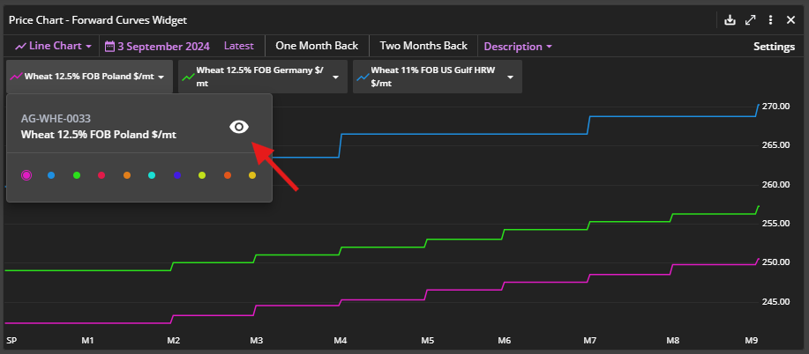

Tips for making the most out of the Price Chart with Forward Curves

* Use latest, one month back, two months back etc to quickly plot a line chart with the forward curve data for all instruments you have added to the widget. Tip: if it gets crowded, click on the tile of a price and then click on the “eye” icon to hide the price in the chart. You can unhide it quickly too.
* Switch between line chart and data table to see the data in the format you like.

Here is an example of a Price Chart with a couple of prices with forward curves in a Data Table.

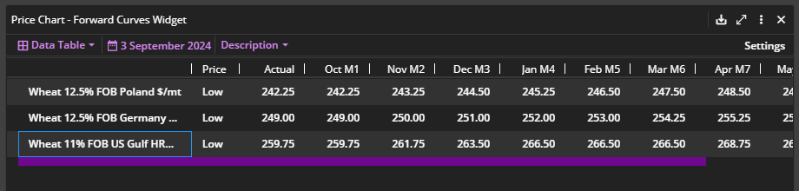

* The same applies in the Multi Price Table - you can export the data from the widget to Fastmarkets Excel Add-in, and/or Excel. **Additionally, the line chart view can be exported as a PNG image.**

A pro tip: you can also search for a price and create a widget directly from the Global Search which can be found at the top left of your Dashboard. This Search also displays the price labels for all prices that have forward curves data. Upon selecting the relevant price, please select the widget type - remember that **only the Multi Price Table and Price Chart** support forward curves data visualization.

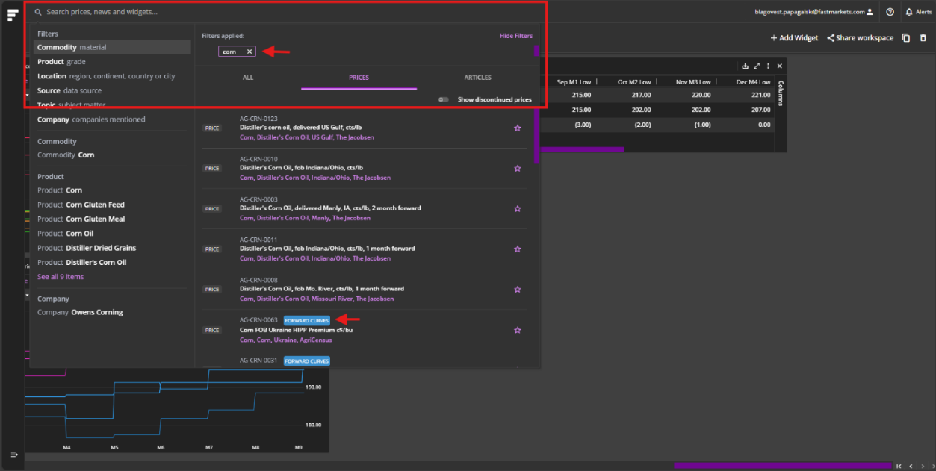

Finally, you are also able to extract the historical data for instruments with forward curves through the Fastmarkets Excel Add-in. Use the “GetPriceHistory” function and ensure you add the forward curve instrument in the additional fields.

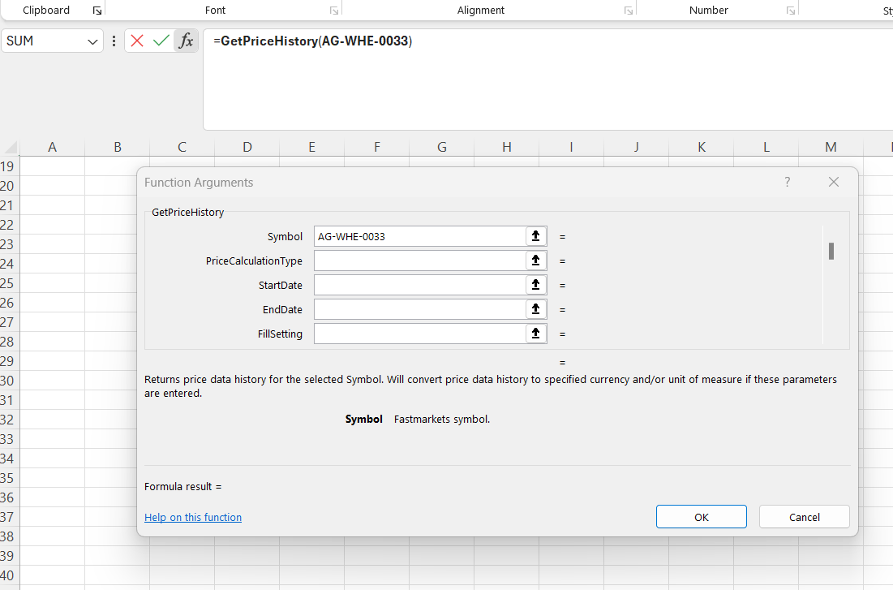

To pull historical data for forward curves use M1Low, M1Mid, or M1High to pull respectively the low, mid, or high values historically. Follow the same syntax for the rest of the forward curve months, e.g. M2Low, M3Low, and M4Low, etc. Once you’re ready with the setup of your function, click OK.

Historical data will flow through into Excel.

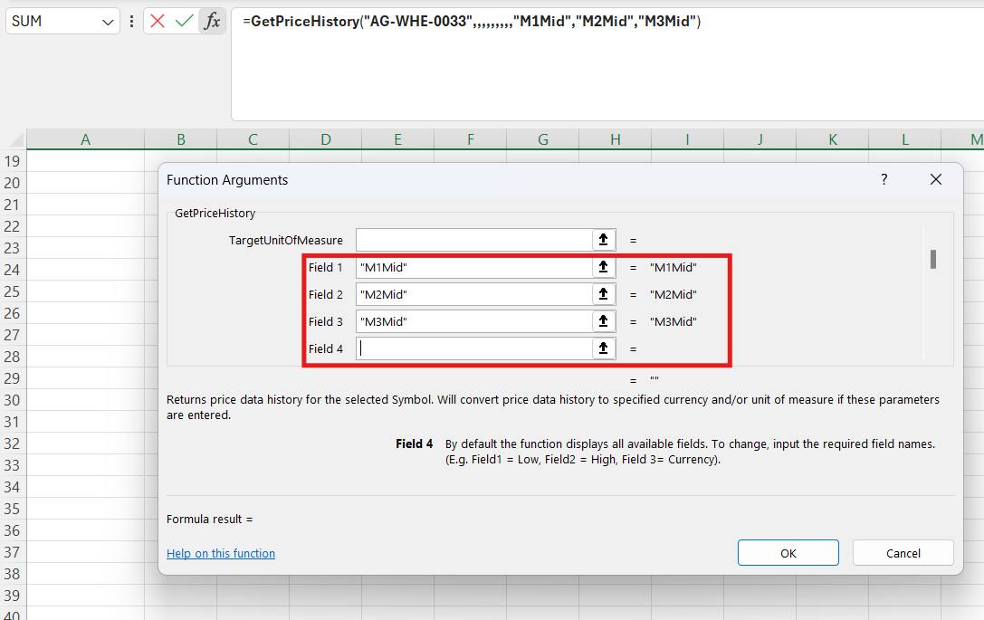 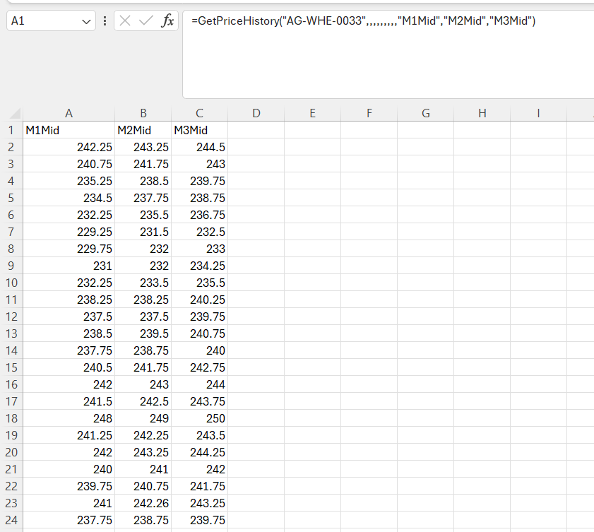

**Login Screen Improvement**

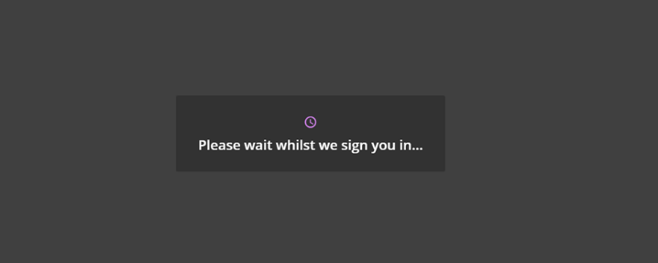

We have received feedback from customers that the login holding screen could be improved. The screenshot above shows the new holding screen. If the user is kept on this screen for longer than 10 seconds the message updates to show the below screenshot, which encourages clients to wait a little longer until giving up and retrying the login process.

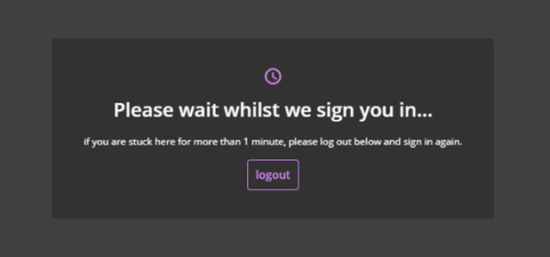

**Easily add new widgets from any Marketpages to your Workspace**

When viewing a Marketpage, you can now just add any widget contained in that page straight into your own Workspace.

Marketpages can be found in the left hand menu of your Dashboard and allow you to browse Fastmarkets news and prices.

We have just released a new prominent “Add to Workspace” button on each widget in Marketpages, this means you no longer have to save the whole screen and can cherry pick the widgets you would like to keep.

**More prominent Scroll bars in the Dashboard**

The previous scroll bars in the Dashboard had very light colours and “blended in” with the Dashboard.

To make the scrollbars more prominent and accessible to users with visual impairments the scroll bar colour has been changed to stand out clearly. Notice the purple scroll bar which enables you to view more fields in this widget.

**Maximise widget to whole screen**

The released new feature allows a user to click the “expand arrow” button to expand the widget to the whole screen for easier interaction.

In this example you can see the chart is small and difficult to see. Clicking on the “expand arrow” will allow the chart to be expanded.

You can then click the X button in the top right of the widget and it will return the widget to its normal size.

All interactions and changes made in this view will be kept when returned back to the workspace view.

**Further help**

If after reading these instructions you have further questions about how to use the Fastmarkets Dashboard, please contact our Customer Success teams or for access/order queries our Client Services team:

* **Europe, Middle East and Africa: +44 20 3855 5581**
* **Asia: +65 3163 3458**
* **Americas: +1 708 329 2641**
* **Customer Success Email:** [***customersuccess@fastmarkets.com***](mailto:customersuccess@fastmarkets.com)
* **Client Services Email:** [***client.services@fastmarkets.com***](mailto:client.services@fastmarkets.com)

For more information on Fastmarkets’ products and services, please use the following links:

* **Pricing data:** <https://www.fastmarkets.com/what-we-do/pricing-data>
* **Pricing notices:** <https://www.fastmarkets.com/about-us/methodology/pricing-notices>
* **Methodology:** <https://www.fastmarkets.com/about-us/methodology>
* **Data Licensing:** <https://www.fastmarkets.com/solutions/data-licensing>